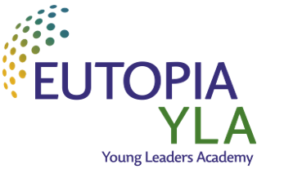
Dear colleague,
The EUTOPIA Alliance is pleased to announce the launch of the third call of the EUTOPIA Young Leaders Academy!
What?
- The objective of the Academy is to support the career development of high-potential, early to mid-career researchers from all EUTOPIA partner universities and to promote interdisciplinary scholarly exchange between promising researchers and the rest of the EUTOPIA research community
How?
- The Young Leaders Academy will enroll a third cohort of 22 fellows (2 per university plus 1 per participating global partner) in November 2024, for a duration of 2 years during which they will become ambassadors of the EUTOPIA alliance.
- It will organize scholarly exchanges and networking activities, skill development and training sessions and visits aimed at acquainting the fellows with the research environment of the EUTOPIA Alliance.
- Fellows will receive a dedicated mobility budget to support their research collaboration projects within EUTOPIA.
Apply!
- Applications are invited from researchers appointed within one of the EUTOPIA universities, or participating Global Partners, holding a tenured or tenure-track position or major research fellowship, between 2 to 12 years after PhD completion;
- Applications will open 28 March and close 28 May 2024 – they will have to be submitted to the local program manager of your home university, including a collaboration and career development project and supported by heads of department, faculty, etc.

More information: https://eutopia-university.eu/young-leaders-academy/
Contact:
Romana Emilia Cramarenco
E-mail: romana.cramarenco@ubbcluj.ro

Sincerely,
Niculina Hadade
E-mail: niculina.hadade@ubbcluj.ro
EUTOPIA YLA Academic Lead

