Delete the text marked in red when filling out the form.
For the text marked in blue, please select the relevant option according to the curriculum.

COURSE DESCRIPTION
(Course title)
Academic year ...............

1. Programme-related data

1.1. Higher Education Institution

1.2. Faculty

1.3. Department
1.4. Field
1.5. Level of study

1.6. Degree programme / Qualification

1.7. Form of education

2. Course-related data
2.1. Course title |  |  |  |  |  |  | Course code
2.2. Course coordinator
2.3. Seminar coordinator
2.4. Year of study |  |  | 2.5. Semester |  | 2.6. Type of assessment | Exam
2.7. Course status |  |  | Compulsory |  | 2.8. Course type | Core subject

3. Total estimated time (hours per semester of teaching activities)
3.1. Number of hours per week |  | of which: 3.2. course |  | 3.3. seminar/ laboratory/ project
3.4. Total of hours in the curriculum |  | of which: 3.5. course |  | 3.6. seminar/ laboratory
Time allocation for individual study (IS) and self-taught activities (ST) |  |  |  |  | hours
Learning from textbooks, course materials, bibliography, and notes (IS)

Additional research in the library, on subject-specific electronic platforms, and on-site

Preparing seminars/ laboratories/ projects, assignments, reports, portfolios, and essays (greater than or equal to the total number of hours specified in the course calendar for evaluation tasks)

Tutoring (professional guidance)

Examinations

Other activities [i.e.: two-way communication with the course coordinator/tutor]

3.7. Total hours of individual study (IS) and self-taught activities (ST)

3.8. Total hours per semester

3.9. Number of credits

4. Prerequisites (where applicable)
4.1. curriculum-related
4.2 skills-related

5. Specific conditions (where applicable)
5.1. course-related
5.2. seminar/laboratory-related
6.1. Competencies resulting from the completion of the degree programme (as referred to in the curriculum)
Professional competencies
Competency code | Competency
PC1 | ...
PC4 | ...
PC5 | ...
Transversal competencies
Competency code | Competency
TC2 | ...
TC3 | ...

6.2. Learning outcomes relevant to the degree programme (as referred to in the curriculum)
Learning outcomes targeted by the subject
Competency code | Knowledge and comprehension | Specific academic skills
PC1 | 1. | 1.
PC4 | 2. | 2.
PC5 | 3. | 3.
TC2 | ... | ...
TC3 | ... | ...

7. Subject-specific learning outcomes (referred to by each subject coordinator across the range of competencies and learning outcomes at the level of the degree programme)
Knowledge and comprehension
1. ...
2. ...
3. ...
4. ...
Specific academic skills
1. ...
2. ...
3. ...

8. Contents
8.1. Course | Teaching and learning methods | Remarks
Bibliography
8.2. Seminar/ laboratory | Teaching and learning methods | Remarks
Bibliography

9. Evaluation
Type of activity | 9.1 Evaluation criteria | 9.2 Evaluation methods | 9.3 Percentage in the final grade
9.4. Course
9.5. Seminar/ laboratory
9.6 Minimum standard for passing
...

10. SDG labels (Sustainable Development Goals)
 |  | Sustainable Development Generic Label
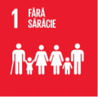 | 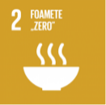 |  | 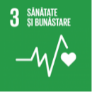 | 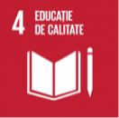 | 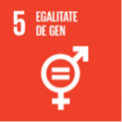 | 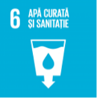 | 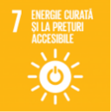 | 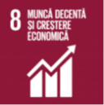 | 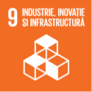
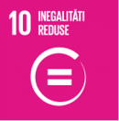 | 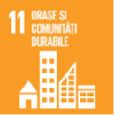 |  | 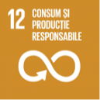 | 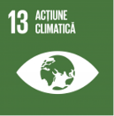 | 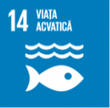 | 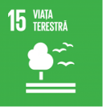 | 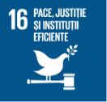 | 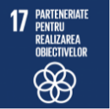 | No label applies

Date of entry:  ... | Signature of course coordinator  ..................... |  | Signature of seminar coordinator  .....................
Date of approval in the department:  ... |  | Signature of the head of department  .....................

The professional and/or transversal skills targeted by the subject for which the course description is prepared will be copied from the curriculum of the degree programme. For each competency, the complete entry, including the competency code, will be copied with the exact wording that appears in the curriculum, without any changes. If no competency is copied from either of the two categories, the row corresponding to that category is deleted from the table.
The learning outcomes relevant for the degree programme and targeted by the subject for which the course description is prepared will be listed. The entries, copied without any changes from the Curriculum by subject type (Core Subject/Specialisation Subject/Complementary Subject), are listed under the corresponding competency.
For example, organisational aspects, recommendations for students, specific aspects relating to the course/seminar, such as inviting experts in the field, etc.
The evaluation criteria must directly reflect the learning outcomes targeted at the level of the degree programme respectively at the level of the subject. More specifically, the learning outcomes set out in the expected learning outcomes are assessed.
Both final evaluation methods and ongoing evaluation strategies should be established.
Select a single label which, according to the Implementation of SDG labels in the academic process, best matches the subject. If the subject addresses sustainable development in a generic manner (i.e. by presenting/introducing the general framework of sustainable development, etc.), then the Sustainable Development generic label may be applied. If none of the labels describe the subject, select the last option: “No label applies.”

